CSA1709 - Artificial Intelligence - SLOT: B

Lab Experiments

Experiment 13: Minimax Algorithm for Gaming

Aim : To implement the Minimax algorithm in Python for a two-player game and determine the best possible move for a player by considering all possible game states.

Algorithm :
- Create a game state or game tree.
- Define terminal states with their utility values.
- The Maximizer tries to obtain the maximum score.
- The Minimizer tries to obtain the minimum score.
- Recursively evaluate all possible moves.
- Select the maximum value for the Maximizer.
- Select the minimum value for the Minimizer.
- Continue until the optimal move is obtained.
- Display the best move and its score.
Program :
def minimax(depth, node, maximizing_player, tree):
if depth == 3:
return tree[node]
if maximizing_player:
best = -9999
for child in [2 * node, 2 * node + 1]:
value = minimax(depth + 1, child, False, tree)
best = max(best, value)
return best
else:
best = 9999
for child in [2 * node, 2 * node + 1]:
value = minimax(depth + 1, child, True, tree)
best = min(best, value)
return best
tree = {
8: 3,
9: 5,
10: 2,
11: 9,
12: 12,
13: 5,
14: 23,
15: 23
}
best_value = minimax(0, 1, True, tree)
print("Best value using Minimax:", best_value)

Sample Input:
Game Tree Leaf Values:
3 5 2 9 12 5 23 23

Output :
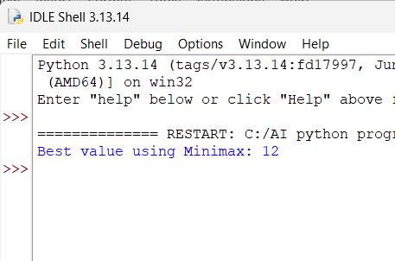

Result:
Thus, the Minimax algorithm was successfully implemented in Python to determine the best possible outcome for the maximizing player in a two-player game.

Experiment 14. Alpha-Beta Pruning Algorithm for Gaming

Aim: To implement the Alpha-Beta Pruning algorithm in Python to optimize the Minimax search by eliminating branches that cannot affect the final decision.

Algorithm:
- Start with the root node of the game tree.
- Initialize Alpha = -∞ and Beta = +∞.
- Alpha represents the best value found for the Maximizer.
- Beta represents the best value found for the Minimizer.
- Explore the game tree recursively.
- For Maximizer, update Alpha with the maximum value.
- For Minimizer, update Beta with the minimum value.
- If Beta ≤ Alpha, stop exploring the remaining branches.
- Return the optimal value.
- Display the best value obtained.

Program:
def alpha_beta(depth, node, maximizing_player,
alpha, beta, tree):
if depth == 3:
return tree[node]
if maximizing_player:
best = -9999
for child in [2 * node, 2 * node + 1]:
value = alpha_beta(
depth + 1,
child,
False,
alpha,
beta,
tree
)
best = max(best, value)
alpha = max(alpha, best)
if beta <= alpha:
break
return best
else:
best = 9999
for child in [2 * node, 2 * node + 1]:
value = alpha_beta(
depth + 1,
child,
True,
alpha,
beta,
tree
)
best = min(best, value)
beta = min(beta, best)
if beta <= alpha:
break
return best
tree = {
8: 3,
9: 5,
10: 2,
11: 9,
12: 12,
13: 5,
14: 23,
15: 23
}
alpha = -9999
beta = 9999
best_value = alpha_beta(
0, 1, True,
alpha, beta, tree
)
print("Best value using Alpha-Beta Pruning:", best_value)

Sample Input:
Game Tree Leaf Values:
3 5 2 9 12 5 23 23

Output:
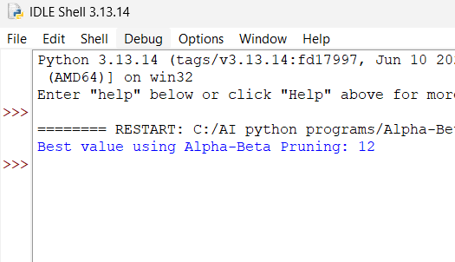

Result:
Thus, the Alpha-Beta Pruning algorithm was successfully implemented in Python. It obtained the optimal value while reducing unnecessary exploration of the game tree.

Experiment 15. Decision Tree

Aim: To implement a Decision Tree classification algorithm in Python and classify data based on its features.

Algorithm:
- Import the required libraries.
- Create a dataset containing input features and target classes.
- Separate the features and target values.
- Create a Decision Tree Classifier.
- Train the classifier using the dataset.
- Provide a new input for prediction.
- Predict the class of the new input.
- Display the predicted result.

Program:
data = [
["Sunny", "Hot", "Yes"],
["Sunny", "Cold", "Yes"],
["Rainy", "Hot", "No"],
["Rainy", "Cold", "No"],
["Sunny", "Hot", "Yes"],
["Rainy", "Cold", "No"]
]
def decision_tree(weather, temperature):
if weather == "Sunny":
return "Yes"
elif weather == "Rainy":
return "No"
else:
return "Unknown"
print("Decision Tree Classification")
weather = input("Enter Weather (Sunny/Rainy): ")
temperature = input("Enter Temperature (Hot/Cold): ")
result = decision_tree(weather, temperature)
print("Weather:", weather)
print("Temperature:", temperature)
print("Prediction:", result)

Sample Input :
Enter Weather (Rainy, Sunny): Sunny
Enter Temperature (Cold, Hot): Hot

Output:
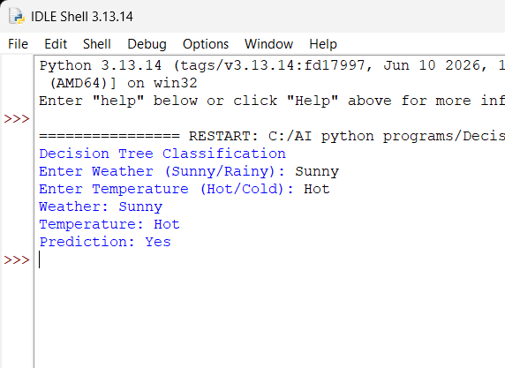

Result :
Thus, the Decision Tree classification algorithm was successfully implemented in Python and used to predict the class of a new data instance.

Experiment 16. Feed Forward Neural Network

Aim: To implement a Feed Forward Neural Network (FFNN) in Python for classification. The network passes input data forward through the hidden layer to the output layer without feedback connections.

Algorithm:
- Import the required libraries.
- Prepare the input dataset and target values.
- Divide the dataset into training and testing data.
- Create a feed-forward neural network.
- Define the input, hidden, and output layers.
- Train the neural network using the training data.
- Test the trained model using test data.
- Calculate the prediction accuracy.
- Display the predicted and actual values.

Program:
import math
def sigmoid(x):
return 1 / (1 + math.exp(-x))
x1 = float(input("Enter first input (0 or 1): "))
x2 = float(input("Enter second input (0 or 1): "))
w1 = 0.5
w2 = 0.5
b1 = 0.5
hidden_input = (x1 * w1) + (x2 * w2) + b1
hidden_output = sigmoid(hidden_input)
w3 = 1.0
b2 = -0.5
output_input = (hidden_output * w3) + b2
output = sigmoid(output_input)
print("\nFeed Forward Neural Network")
print("----------------------------")
print("Input 1 :", x1)
print("Input 2 :", x2)
print("Hidden Output :", round(hidden_output, 4))
print("Final Output :", round(output, 4))
if output >= 0.5:
print("Prediction : 1")
else:
print("Prediction : 0")

Sample Input

Enter first input (0 or 1): 1

Enter second input (0 or 1): 1

Output :
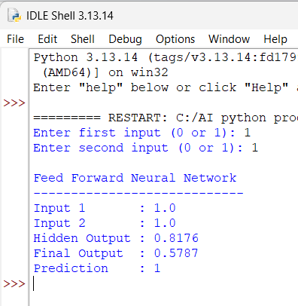

Result:
Thus, the Feed Forward Neural Network was successfully implemented in Python and trained to classify the given input data.

